**Group 4 - The Budget Hawk**

**ITSC 3155 Final Project Proposal**

**Prepared by: 5/1/2021**

**Date: 5/2/2021**

**Table of Contents**

**1 Introduction 4**

1.1 Product Vision 4

1.2 Customer Description 4-5

1.3 Project Scope and Objectives 5

**2 Project Resources 5**

2.1 Group Members 5

2.2 Data 6

2.3 Hardware and Software Resources 6

2.4 Special Resources 7

**3 Plan 7**

3.1 Timeline Chart 7

3.2 Task/Milestone Descriptions 7-9

3.3 Resource Table 9-12

**4 System Design** 13

4.1 Use Case Diagram 13-15

4.2 DFD diagram 16-17

4.3 User Stories 17-18

4.4 Feature List 19

4.5 Storyboard 19-20

**5 User Tests 20**

5.1 Test procedure 20

5.2 User Test and Results 21

5.3 Conclusion 21

**6 Lessons Learned 21**

**7 Future work 22**

**8 Appendices 22**

8.1 Sketches 22-24

8.2 Software Repository 24

8.3 WBS tool 25

**9 Additional Information 25**

# 1 Introduction

Recently the media has been plagued with reactions and analyses of police actions against suspects and other civilians. The outrage by the public called for the defunding of police departments as they were deemed unnecessary or excessive in how they protected communities. The ways in which police have handled past cases varies, but it heavily relies not only on the personnel they employ, but also the budget given to them. Higher budgets and costs are mainly for those departments who are in high crime-ridden areas where there is a huge need for resources for police officers to use to protect the general public.

This raises the question of how much is actually necessary for police departments to be able to effectively protect the people and enforce laws? It’s given that when there is a lot of crime, a lot of money is needed to sort out and solve these problems; however, what happens when crime rates go back down? How can we tell how the budget should be adjusted when the crime rates seem to dwindle? There is a need for regulation and efficiency in the budgets provided to police departments, so the departments can protect the community without putting a strain on the rest of the government budgets needed for regulation of the community.

## 1.1 Product Vision

Our new website named “The Budget Hawk” seeks to minimize budgetary expenditures in various cities and states by comparing police department spending against crime rates reported by the FBI. Thus, allowing for policy makers in those cities and states to minimize and properly prioritize their budgets if crime rates have been reliably declining.

1.2 Customer Description

Our application is targeted towards policy makers in cities and states and concerned citizens.

## 1.3 Project Scope and Objectives

The overall objective of our application called “The Budget Hawk” is to prevent overspending within a state/city. The main features will be the ability for policy makers to pull crime records from the FBI and compare them. Once this information is processed “The Budget Hawk” will create a series of easily readable graphs based on the selected states and cities.

## 1.4 Ethical Concerns

Although the information used by “The Budget Hawk” is publicly available, one possible concern is that bad actors could use graphs generated to misrepresent the data provided.

# 2 Project Resources

## 2.1 Group Members

1. Austin Smith
2. Jack Hamilton
3. Kevin Hudson
4. Kylee Mucher

## 2.2 Data

### First dataset:

TheMarshallProject crime numbers for US cities from 1975-2015: <https://github.com/themarshallproject/city-crime/blob/master/data/ucr_crime_1975_2015.csv>

This source is the 2017 crimes reports in the United States of America directly from TheMarshallProject which pulled the numbers from the FBI. This source when paired with the fiscal spending of police departments in 2017 illustrates that police department funding increases with no correlation to the crime rates reported by the FBI.

### Second dataset:

FiSC database for police spending: <https://www.lincolninst.edu/research-data/data-toolkits/fiscally-standardized-cities/search-database>

This source is the fiscal spending of every police department in the United States of America in 2017 from the Lincoln Institute of Land Policy. This datasets allows our group to establish what various select cities budgetary expenditures are for their police departments. When paired with the crime reports from the FBI we can establish that police department funding increases regardless of the crime rates within their policing jurisdiction.

## 2.3 Hardware and Software Resources

The minimum requirements for running our application is a computer that meets the requirements to run a python file using Dash Plotly.

## 2.4 Special Resources

The only special resource utilized for this project was Dash Plotly.

# 3 Plan

## 3.1 Timeline Chart

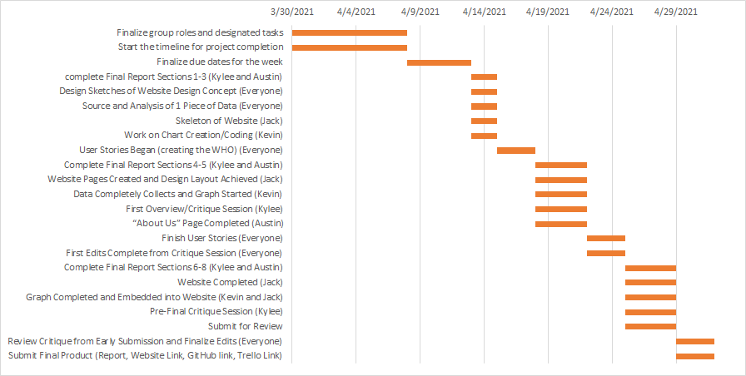

## 3.2 Task/Milestone Descriptions

### To Do by April 8th:

* Finalize Group Roles and Designated Tasks
* Start the Timeline for Project Completion

### To Do by April 13th:

* Finalize due dates for the week

### To Do by April 15th:

* Complete Final Report Sections 1-3 (Kylee and Austin)
* Design Sketches of Website Design Concept (Everyone)
  + Add to GitHub
* Source and Analysis of 1 Piece of Data (Everyone)
* Skeleton of Website (Jack)
  + Add Screenshot to GitHub
* Work on Chart Creation/Coding (Kevin)
  + Add Code to GitHub

### To Do by April 18th:

* User Stories Began (creating the WHO) (Everyone)

### To Do by April 22nd:

* Complete Final Report Sections 4-5 (Kylee and Austin)
* Website Pages Created and Design Layout Achieved (Jack)
  + Add a Few Screenshots to GitHub
* Data Completely Collects and Graph Started (Kevin)
  + Add Code to GitHub
* First Overview/Critique Session (Kylee)
  + Add List of Concerns/Suggestions to GitHub
* “Data Sources” Page Completed (Austin)

### To Do by April 25th:

* Finish User Stories (Everyone)
  + Add to GitHub
* First Edits Complete from Critique Session (Everyone)

### To Do by April 29th:

* Complete Final Report Sections 6-8 (Kylee and Austin)
* Website Completed (Jack)
  + Add a Screenshot of Each Page to GitHub
* Graph Completed and Embedded into Website (Kevin and Jack)
  + Add Screenshot and Code to GitHub
* Pre-Final Critique Session (Kylee)
  + Add List of Concerns/Suggestions to GitHub
* Submit for Review

### To Do by May 2nd:

* Review Critique from Early Submission and Finalize Edits (Everyone)
* Submit Final Product (Report, Website Link, GitHub link, Trello Link)

## 3.3 Resource Table

Actual contributions of group members

|  |  |
| --- | --- |
| Task | People |
| Finalize group roles and designated tasks | Everyone |
| Start the timeline for project completion | Everyone |
| Finalize due dates for the week | Everyone |
| complete Final Report Sections 1-3 (Kylee and Austin) | Kylee and Austin |
| Design Sketches of Website Design Concept (Everyone) | Everyone |
| Source and Analysis of 1 Piece of Data (Everyone) | Everyone |
| Skeleton of Website (Austin) | Austin |
| Work on Chart Creation/Coding (Austin) | Austin |
| User Stories Began (creating the WHO) (Everyone) | Everyone |
| Complete Final Report Sections 4-5 (Kylee and Austin) | Kylee and Austin |
| Website Pages Created and Design Layout Achieved (Austin) | Austin |
| Data Completely Collects and Graph Started (Austin) | Austin |
| First Overview/Critique Session (Kylee) | Kylee and Austin |
| “About Us” Page Completed (Austin) | Austin |
| Finish User Stories (Everyone) | Everyone |
| First Edits Complete from Critique Session (Everyone) | Everyone |
| Complete Final Report Sections 6-8 (Kylee and Austin) | Kylee and Austin |
| Website Completed (Austin) | Austin |
| Graph Completed and Embedded into Website (Austin) | Austin |
| Pre-Final Critique Session (Kylee) | Kylee |
| Submit for Review | Everyone |
| Review Critique from Early Submission and Finalize Edits (Everyone) | Everyone |
| Submit Final Product (Report, Website Link, GitHub link, Trello Link) | Everyone |

# 4 System Design

## 4.1 Use Case Diagram

Kylee:

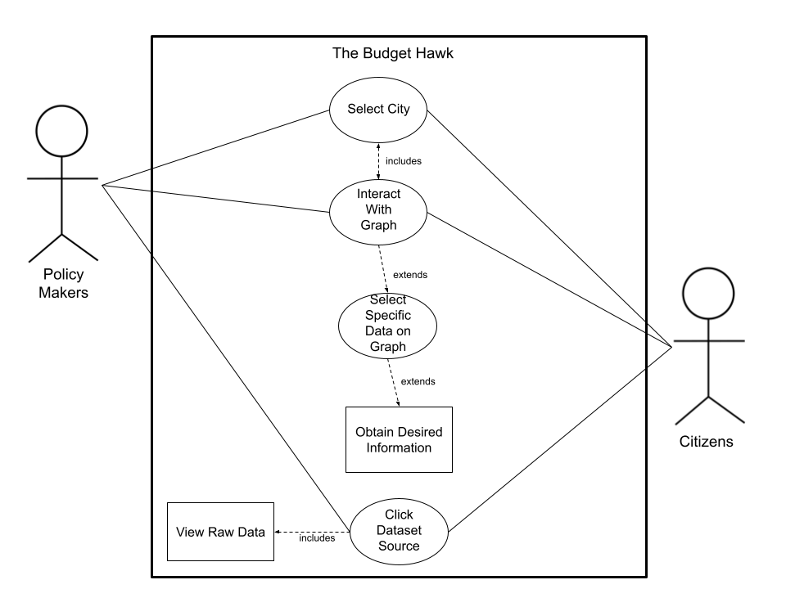

Jack:

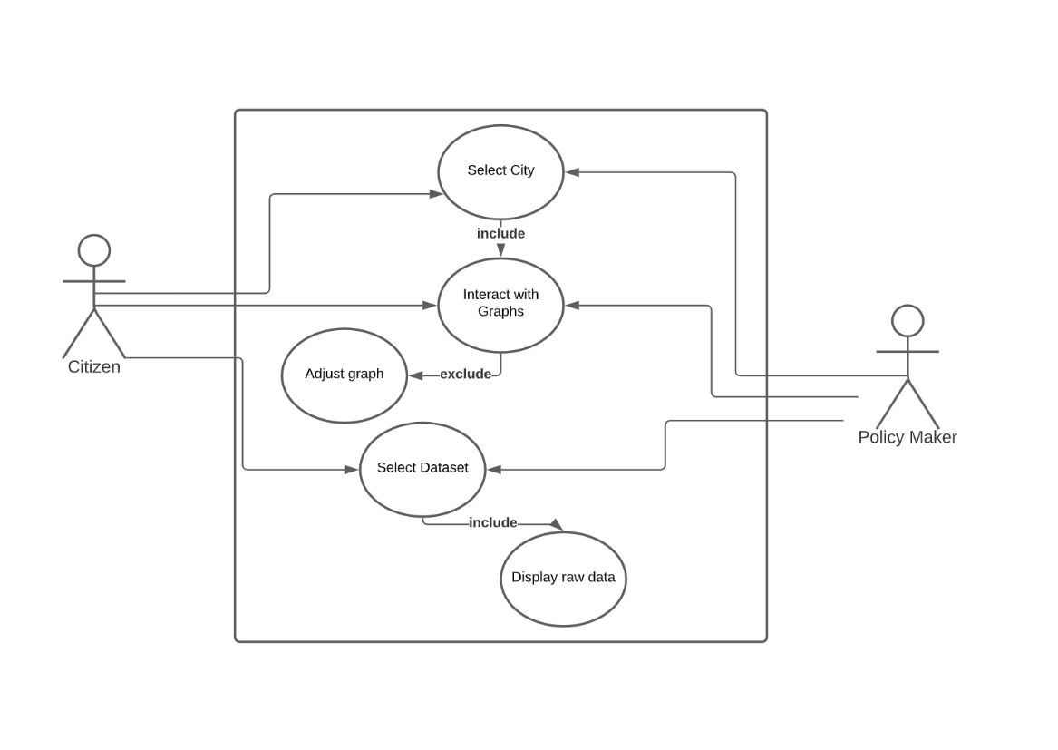

Austin:

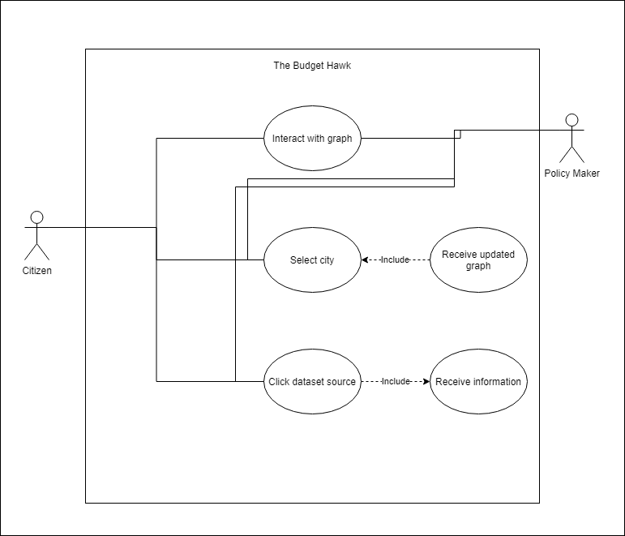

Kevin:

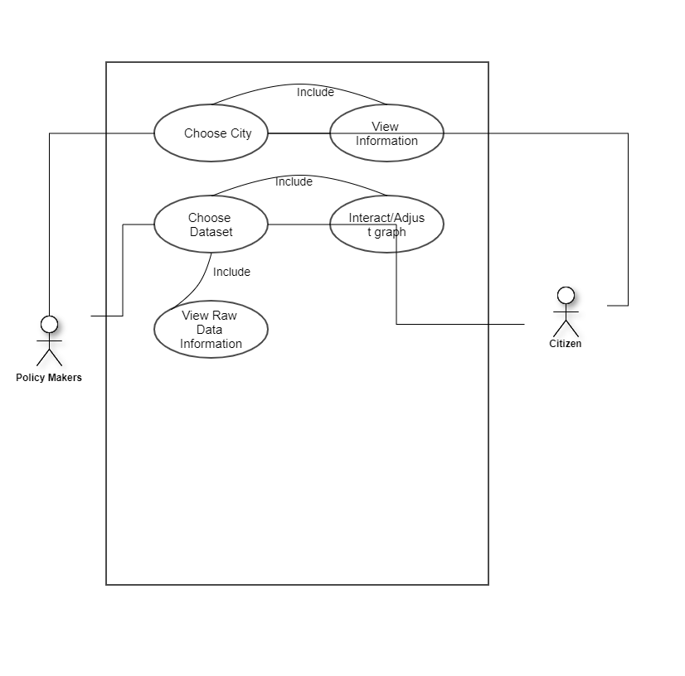

## 4.2 DFD diagram Kevin:

Austin: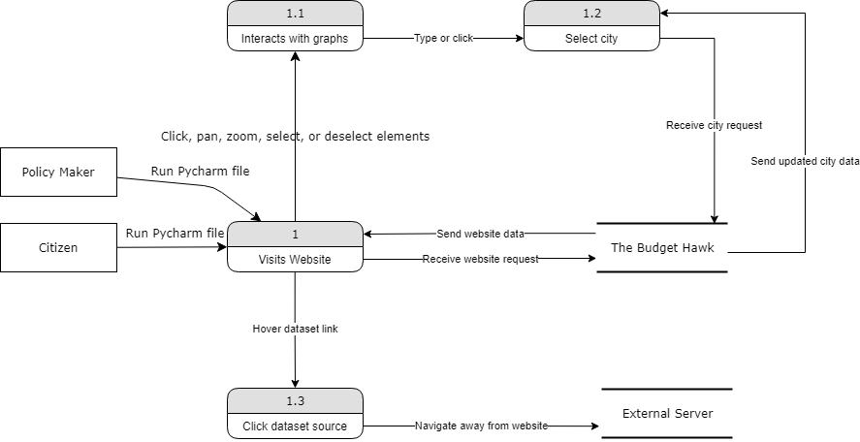

## 4.3 User Stories

Austin:

Karen:

Karen is a middle-aged woman that likes to do her own research. She worries about her community with recent calls to defund her local police department, so she wanted to see the facts for herself. She wants to see how police department funding compares to other departments and the crime rates within her city.

Trayvon:

Trayvon is a young man that has recently become engaged in local activism. He wants to track how much his local city budget has been allocated to police departments over the years. He’s specifically seeking to find information that proves police department funding has increased independent of crime rates, so he can sway his fellow community members and elected representatives at local meetings.

Tobin:

Tobin is a local representative that is seeking to quickly inform himself about the history of the allocation of the city’s budget. He is seeking to compare police department funding to crime rates specifically violent crimes within his city. He wants this information to be easily readable and understandable, so his constituents will be able to understand it.

Kylee:

* 1. Freya Halstead  
     Freya is the new police chief for her department and is trying to see how to be more efficient on their spending. After going through some of the account books, she notices that there is a surplus of funds in the department going unused. She becomes curious about whether this is happening in other departments as well.

Kevin:

* 1. Devin is a citizen that feels that police sources in their city are being wasted/overfunded when their budget could be used for other things that could benefit the community. He checks this website to see the actual budget of the police force in his city along with related data.
  2. Josh noticed that crime rates have been decreasing in his city as a result to a recent budget change in his city. He would like to see the relationship between the budget change and crime rates so he uses the budget hawk to check.

## 4.4 Feature List

* Visual representation of police budget vs types of crimes
  + Interactable by city, type of crime, and type of services.
  + Can pan, zoom in and zoom out, and compare values on hover.
* Visual representation of budgets by departments
* Links and descriptions of sources used
* Written purpose of data collection

## 4.5 Storyboard

Austin: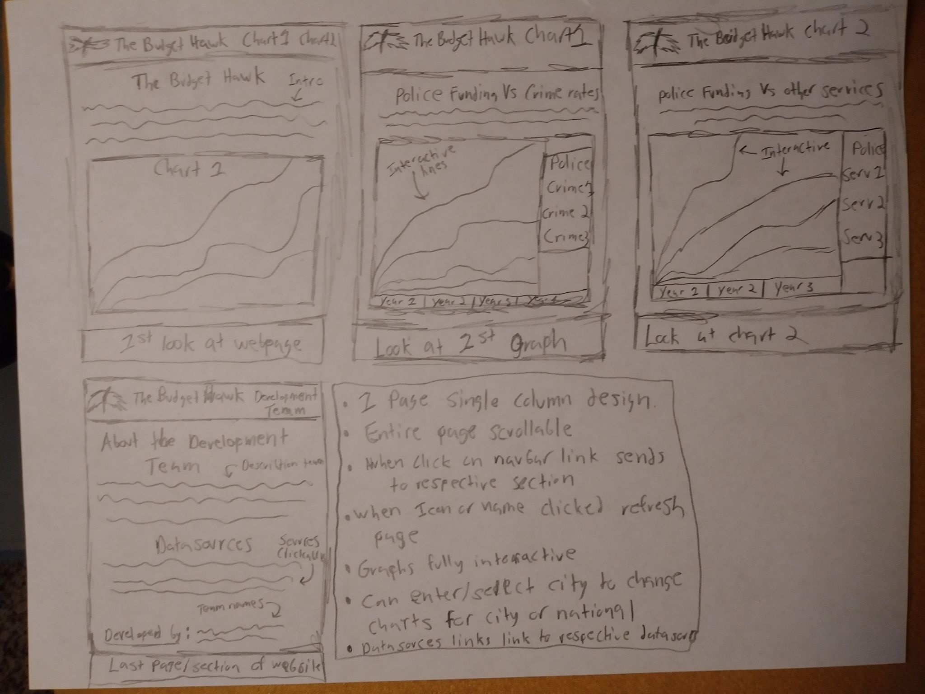

Kevin:

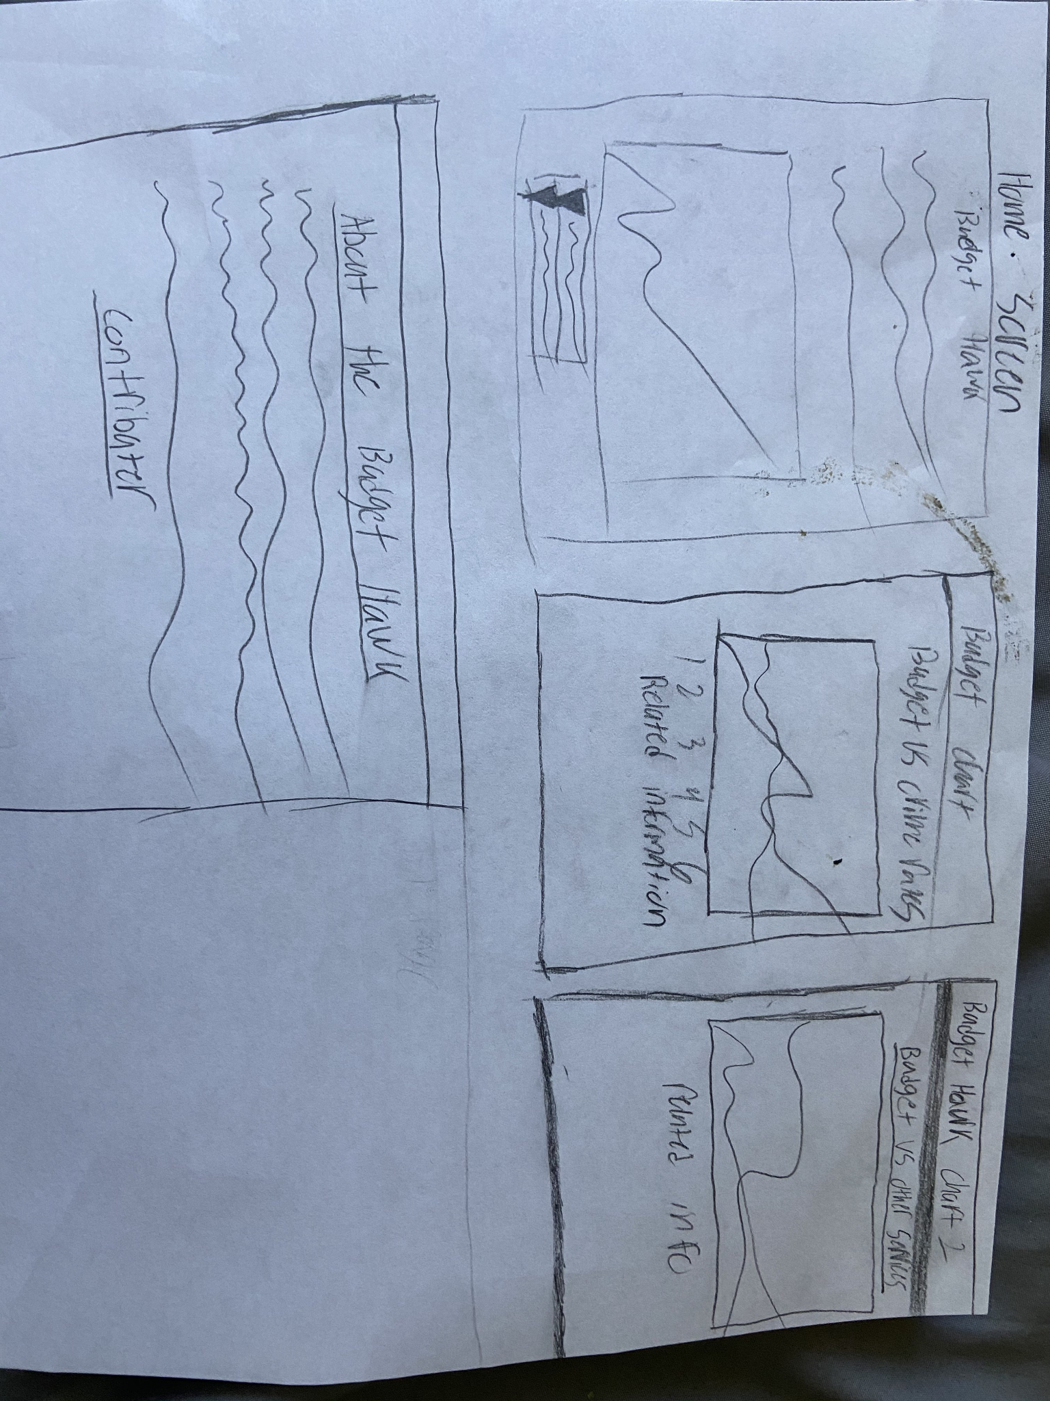

# 5 User Tests

## 5.1 Test procedure

We presented our user stories and application to Group 3 lead by Anders Pierson using Discord's screen sharing feature and they guided our group through our application. They thoroughly analyzed our website and informed us of any inconsistencies and problems that we overlooked.

## 5.2 User Test and Results

Feedback from Group 3 leader Anders Pierson:

The Budget Hawk is a thorough analysis of crime statistics in America, mostly in reference to the budget of governments and the rates of crime corresponding. The project itself is very streamlined and simplistic, delivering to the user a compact statistical analysis that feels smooth and not too much to take in. The one thing that I can deliver criticism about is that some of the data in the graphs is hard to understand as the titles of some of the data do not make sense and are not explained to the user. Other than that, the project delivers a clean analysis of crime rates vs. police budgeting in the United States.

## 5.3 Conclusion

Suggestions from Group 3 were considered and implemented. The application was updated and reuploaded to the github.

# 6 Lessons Learned

Some lessons that we learned through designing this project were:

* There is a need for more descriptions and information, so users are able to understand what they are looking at and how to read/use the data.
* Learned how to code using Dash Plotly and improved our coding skills overall.
* Learned how to obtain data using .csvs files and learned how to utilize that data to generate graphs.

# 7 Future work

Some additional features that our team would wish to implement in the future when time constraints or coding complexing wouldn’t be a problem would be:

* We would like to have the application automatically collect datasets from their respective sources, allowing for the graphs to always stay updated with the latest information.
* We would like the datasets to cover all cities within the United States or hopefully the world. As of right now, our datasets only cover 56 US cities and includes national data for the US. Thus, if we increase the scope of our datasets our application will have increased reach and relevance.

# 8 Appendices

## 8.1 Sketches

Austin:

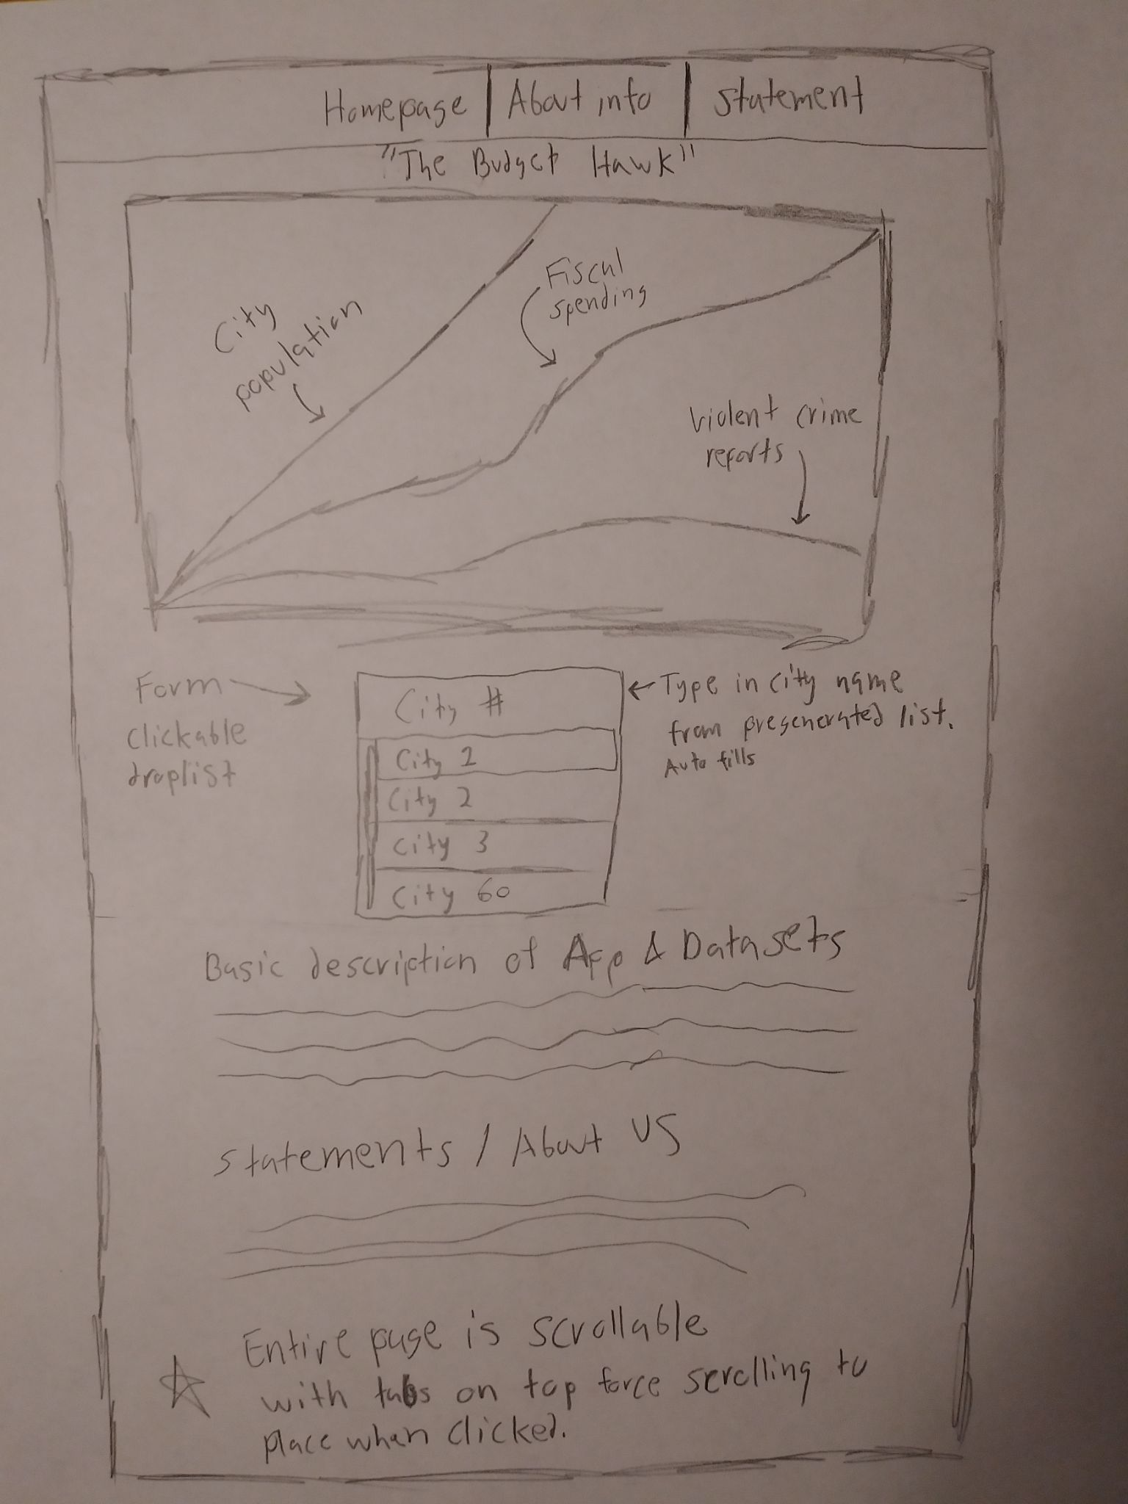

Kevin:   
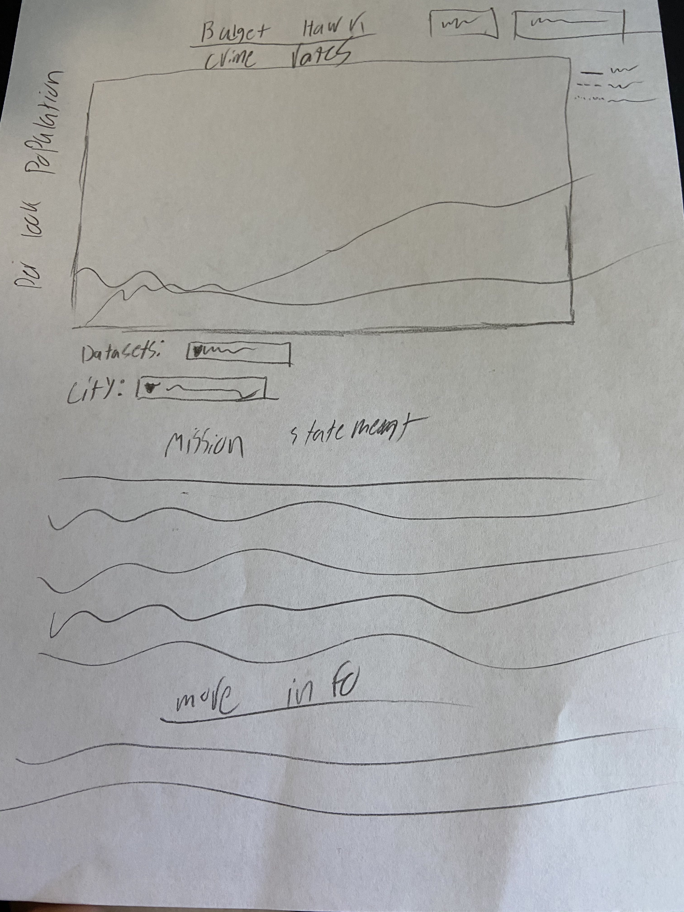

## 8.2 Software Repository

Github:

<https://github.com/AustinMorganSmith/ITSC-3155-Final-Project>

Trello Board:

<https://trello.com/invite/b/SnoKPlMC/14458a2d3a38eb04ebd75b5357313612/itsc-3155-final-project>

8.3 WBS tool

Our team utilized the Trello Board to distribute the workload and a Gantt Chart created utilizing excel. The file for the gantt chart, like every other file, can be obtained from the Github repository in the “Documentation” folder.

Additional Information

### Presentation and demo link**:**

<https://youtu.be/hgvCWdfq4w4>

### Additional Statement**:**

All images and other forms of information present in this report are accessible through the Github repository in the “Documentation” folder under each group member’s respective name.